TS C201 V3.0.0 (1999-10)
Technical Specification
China Wireless Telecommunication Standard (CWTS);
Working Group 1 (WG1);

MAC protocol specification

CWTS

Contents
1.Scope 3
2.References 4
3. Definitions, abbreviations and symbols 5
3.1 Definitions 5
3.2 Abbreviations 5
3.3 Symbols 6
4 General 7
4.1 Objective 7
4.2 Overview on MAC architecture 7
4.2.1 MAC Entities 7
4.2.2 MAC-b, MAC-c and MAC-sy 7
4.2.3 Traffic Related Architecture - UE Side 8
4.2.4. Traffic Related Architecture - RAN Side 11
4.3 Channel structure 14
4.3.1 Transport channels 14
4.3.2 Logical Channels 15
4.3.3 Mapping between logical channels and transport channels 16
5 Services provided to upper layers 16
5.1 Description of Services provided to upper layers 16
6 Functions 16
6.1 Description of the MAC functions 16
6.2 Relation between MAC Functions / Transport Channels and UE 17
6.2.1 Relation between MAC Functions and Transport Channels 17
6.2.2 Relation of UE MAC functions corresponding to the Transport Channel MAC Functions and Transport Channels 19
7 Services expected from physical layer 19
8 Elements for layer-to-layer communication 20
8.1 Primitives between layers 1 and 2 20
8.2 Primitives between MAC and RLC 20
8.2.1 Primitives 20
8.2.2 Parameters 20
8.3 Primitives between MAC and RRC 22
8.3.1 Primitives 22
8.3.2 Parameters 24
9 Elements for peer-to-peer communication 25
9.1 Protocol data units 25
9.1.1 MAC Data PDU 25
9.1.2 MAC Control PDU 25
9.2 Formats and parameters 25
9.2.1 MAC Data PDU: Parameters of the MAC header 25
9.2.2 Control PDUs 28
9.3 Protocol states 28
9.4 State variables 29
9.5 Timers 29
9.6 Protocol Parameters 29
9.7 Specific functions 29
9.7.1 Fast Dynamic Channel Allocation for Bearer Service 29
10 Handling of unknown, unforeseen and erroneous protocol data 30
11 Elementary procedures 30
11.1 Dynamic Radio Bearer control 30
11.2 Control of RACH transmissions 32
12 History 36
Annex A (informative): 36
A.1 Assumptions 37
A.2 Example message sequence for random access procedure 37

1.Scope

The scope of this description is the specification of the MAC protocol.

The following lists the contents for the specification of the MAC protocol:
- list of procedures
- logical flow diagrams for normal procedures
- logical description of message
- principles for error handling
- some exceptional procedures which are felt criteria
- It should, as far as possible, have the same format and outline as the final specification
- exact message format
- all scenarios

Note: The list has to be reviewed.

2.References

The following documents contain provisions which, through reference in this text, constitute provisions of the present document.
- References are either specific (identified by date of publication, edition number, version number, etc.) or non-specific.
- For a specific reference, subsequent revisions do not apply.
- For a non-specific reference, the latest version applies.
- A non-specific reference to an TS shall also be taken to refer to later versions published as an EN with the same number.

[1] TS C001, Radio Interface Protocol Architecture
[2] TS C002, Services provided by the physical Layer
[3] TS C003, UE functions and Interlayer Procedures in Connected Mode
[4] TS C004, UE procedures in Idle Mode
[5] TS C202,RLC protocol specification.
[6] TS C203, RRC protocol specification.

[7] TS 25.391, Description of principles for error handling and message description

[8] ETSI UMTS 25.XX: ”Vocabulary for the RAN”

3. Definitions, abbreviations and symbols

3.1 Definitions

See [8] for a definition of fundamental concepts and vocabulary.

3.2 Abbreviations

ARQ Automatic Repeat Request
ASC Access Service Class
BCCH Broadcast Control Channel
BCH Broadcast Channel
- Control-
CC Call Control
CCCH Common Control Channel
CCTrCH Coded Composite Transport Channel
CPCH Common Packet Channel (UL)
CN Core Network
CRC Cyclic Redundancy Check
DC Dedicated Control (SAP)
DCA Dynamic Channel Allocation
DCCH Dedicated Control Channel
DCH Dedicated Channel
DL Downlink
DRNC Drift Radio Network Controller
DSCH Downlink Shared Channel
DTCH Dedicated Traffic Channel
FACH Forward Link Access Channel
FCS Frame Check Sequence
FDD Frequency Division Duplex
GC General Control (SAP)
HO Handover
ITU International Telecommunication Union
kbps kilo-bits per second
L1 Layer 1 (physical layer)
L2 Layer 2 (data link layer)
L3 Layer 3 (network layer)
LAC Link Access Control
LAI Location Area Identity
MAC Medium Access Control
MM Mobility Management
Nt Notification (SAP)
OCCCH ODMA Common Control Channel
ODCCH ODMA Dedicated Control Channel
ODCH ODMA Dedicated Channel
ODMA Opportunity Driven Multiple Access
ORACH ODMA Random Access Channel
ODTCH ODMA Dedicated Traffic Channel
PCCH Paging Control Channel
PCH Paging Channel
PDU Protocol Data Unit
PHY Physical layer
PhyCH Physical Channels
RACH Random Access Channel
RLC Radio Link Control
RNC Radio Network Controller
RNS Radio Network Subsystem
RNTI Radio Network Temporary Identity
RRC Radio Resource Control
SAP Service Access Point
SCCH Synchronization Control Channel
SCH Synchronization Channel
SHCCH Shared Channel Control Channel
SDU Service Data Unit
SRNC Serving Radio Network Controller
SRNS Serving Radio Network Subsystem
TDD Time Division Duplex
TFCI Transport Format Combination Indicator
TFI Transport Format Indicator
TMSI Temporary Mobile Subscriber Identity
TPC Transmit Power Control
U- User-
UE User Equipment
UE_{R} User Equipment with ODMA relay operation enabled
UL Uplink
UMTS Universal Mobile Telecommunications System
URA RAN Registration Area
USCH Uplink Shared Channel
UTRA UMTS Terrestrial Radio Access
RAN UMTS Terrestrial Radio Access Network

3.3 Symbols

4 General

4.1 Objective

4.2 Overview on MAC architecture
The following provides an overview of MAC architecture that encompasses in TD-SCDMA RAN TDD mode. Followed by section 4.2.1 MAC entities, where the different MAC entities are summarised, the sections 4.2.2-4 contain a more detailed description of the MAC architecture.
Note: The contents have to be reviewed, changes depend on further contributions

4.2.1 MAC Entities
The diagrams that describe the MAC architecture are constructed from MAC entities. The entities are assigned the following names. The functions completed by the entities are different in the UE from those completed in the RAN:
- MAC-b, which identifies the MAC entity that handles the broadcast channel (BCH). There is one MAC-b entity in each UE and one MAC-b in the RAN for each cell.
Note: The separation in two different BCCH is ffs, the control SAP may be split accordingly
- MAC-c, which identifies the MAC entity that handles the forward access channel (FACH), the random access channel (RACH) and the paging channel. There is one MAC-c entity in each UE and one in the RAN for each cell.
- MAC-d, denotes the MAC entity that is responsible for handling of dedicated logical channels and dedicated transport channels (DCH) allocated to a UE. There is one MAC-d entity in the UE and one MAC-d entity in the RAN for each UE.
Note: When a UE is allocated resources for exclusive use by the bearers that it supports the MAC-d entities dynamically share the resources between the bearers and are responsible for selecting the TFI/ TFCI that is to be used in each transmission time interval.
- MAC-sh, denotes the MAC entity that handles downlink shared channels (DSCH) and uplink shared channels (USCH) . There is one MAC-sh entity in each UE that is using a DSCH and a USCH and one MAC-sh entity in the RAN for each cell that contains a DSCH and a USCH
- MAC-sy, identifies the MAC entity used to handle the information received on the synchronisation channel SCH

According to the RRC functions the RRC is generally in control of the internal configuration of the MAC.

4.2.2 MAC-b, MAC-c and MAC-sy
The following diagram illustrates the connectivity of the MAC-b, MAC-c and MAC-sy entities in a UE and in each cell of the RAN:

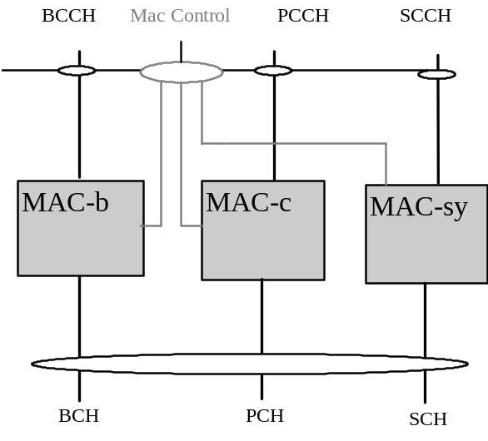

Figure 4.2.2.1 UE side and RAN side architecture (BCCH ,PCCH and SCCH)

MAC-b, MAC-c and MAC-sy represents BCH , PCH and SCH control entities, which are cell-specific MAC entities in the RAN. In the UE side there is one SCH and BCH and PCH control entity per UE. The SCH control entity handles synchronisation channels. The details of this entity are left for further study. The MAC Control SAP is used to transfer Control information to each MAC entity.
Note: In this section, only the PCH control function of MAC-c entities is considered, the other function of MAC-c entities will be described in the following sections

4.2.3 Traffic Related Architecture - UE Side
Figure 4.2.3.1 illustrates the connectivity of MAC entities. The figure shows a MAC-d servicing the needs of several DTCH mapping them to a number of DCH. A MAC-sh controls access to a common transport channel. It is noted that because the MAC-sh provides additional capacity then it communicates only with the MAC-d rather than the DTCH directly. The MAC-c, which interfaces with the PCH, FACH and RACH common transport channels, is connected with the MAC-d for transfer of data and RNTI. The MAC Control SAP is used to transfer Control information to each MAC entity. The SHCCH SAP is used to transfer control information from RRC to MAC-sh. The MAC-sh transfers data from the DSCH to the MAC-d and from the MAC-d to the USCH under control of the FACH.
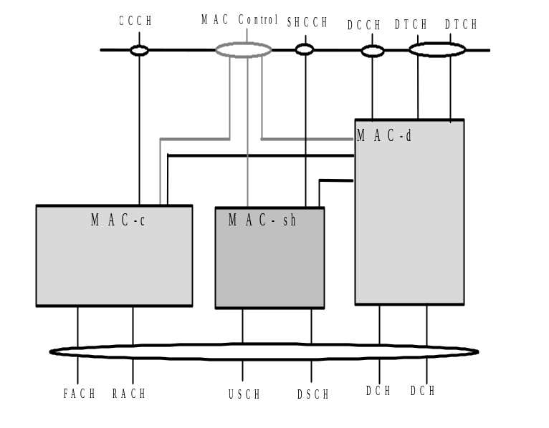

Figure 4.2.3.1 UE side MAC architecture*

*The logical relationship of PCCH, PCH and MAC-c is not illustrated in this Figure in case of the redundancy with Fig. 4.2.2.1

Figure 4.2.3.2 shows the UE side MAC-c entity. The following functionality is covered:
- The C/D MUX box represents the insertion and detection of the field in the MAC header, indicating whether a common or dedicated logical channel is used.
- The D/S MUX box represents the insertion and detection of the field in the MAC header, indicating whether MAC communication to MAC-sh or to a dedicated logical channel is used.
- The c-RNTI field in the MAC header is used to distinguish between UEs. The partial c-RNTI could be used to distinguish between UEs in low chiprate operation mode, the detail of the transfer between completed c-RNTI and partial c-RNTI is ffs.
- In the uplink, the possibility of transport format selection exists.
- Selection of Access Service Classes (ASC) for RACH defined by the System Information message, and its relation to the RACH retransmission algorithm is ffs.
- Multiplexing/scheduling /priority handling is used to transmit the received information on RACH.
- Demultiplexing of received information inside MAC-c to CTCH is used to support Short Message Service Cell Broadcast (SMS CB).
- The allocation box contains functionality required for USCH/DSCH operation.

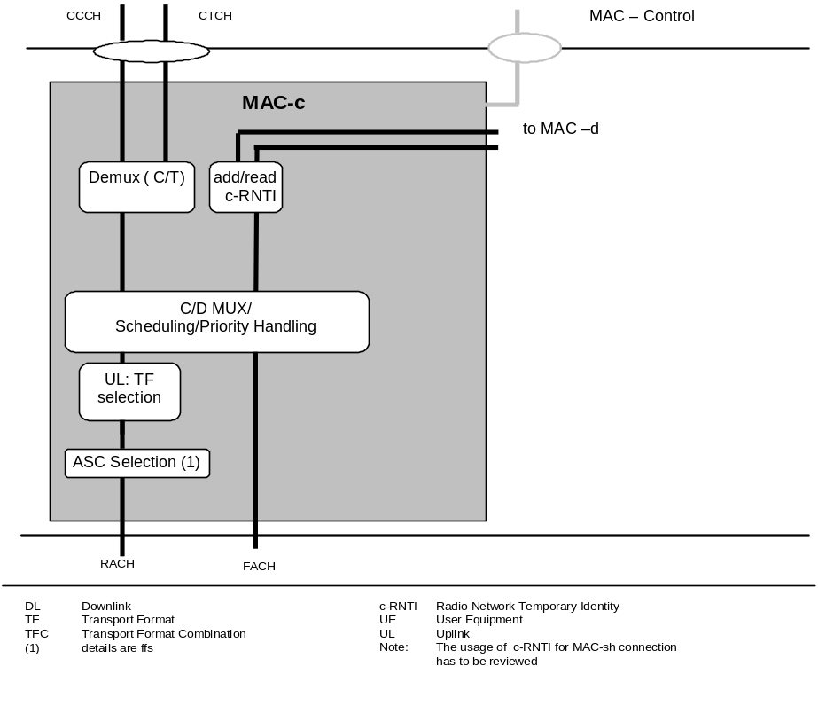

Figure 4.2.3.2. UE side MAC architecture / MAC-c details

Figure 4.2.3.3 shows the UE side MAC-d entity. The following functionality is covered:
- Dynamic transport channel type switching is performed by this entity, based on decision taken by RRC.
- The C/T MUX box is used when multiplexing of several dedicated logical channels onto one transport channel is used.
- The MAC-d entity using common channels is connected to a MAC-c entity that handles the scheduling of the common channels to which the UE is assigned.
- The MAC-d entity using downlink shared channel is connected to a MAC-sh entity that handles the reception of data received on the shared channels to which the UE is assigned.
- In the uplink, transport format combination selection (out of the RRC assigned transport format combination set) is performed to prioritise transport channels.
- Support of Ciphering / Deciphering for transparent RLC operation in MAC , see [2] for details on the concept.
- Ciphering is performed in the MAC-d sub-layer for a transparent RLC mode. Similarly, it is possible that UE may receive services from both CS and PS domain. For example, UE may receive a voice call from Cs-domain, and at the same time, have services from Ps-domain (e.g. voice over IP). In this case, the MAC must apply the appropriate Kc for each bear from different service domain
- At the Radio Bearer Establishment procedure, if a RB is mapped to a RLC TM instance, the SRNC will send the associated Kc to the MAC layer. The MAC layer should know the domain types for both logical channel and Kc in order to perform the right ciphering function.

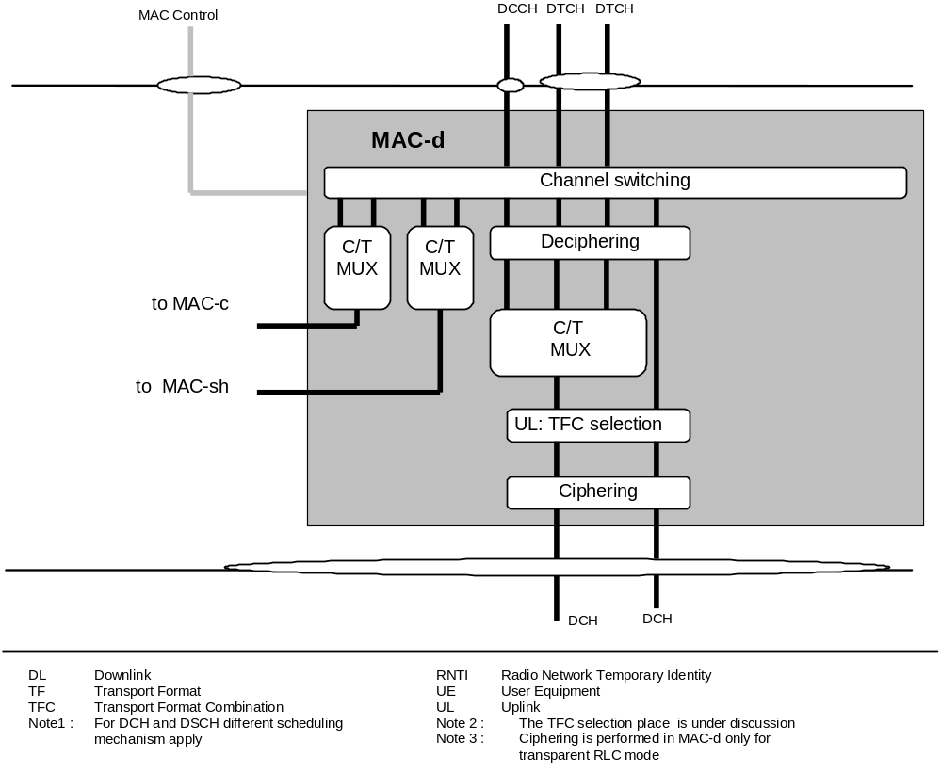

Figure 4.2.3.3. UE side MAC architecture / MAC-d details

Figure 4.2.3.4 shows the UE side MAC-sh entity. The following functionality is covered:

- RNTI is used on the DSCH Control Channel to identify the UE. Additionally, some timing / physical information is needed to tell the UE when to listen to DSCH.
- Multiplexing is used to transmit the received information on DSCH and DSCH Control Channel to the Mac-d, the multiplexing is used to transfer data from MAC-d to USCH and receives control information for shared operation from SHCCH.
- Buffer occupancy information is added to support USCH operation.

The RLC has to provide RLC-PDU’s to the MAC which fits into the available transport blocks on the transport channels respectively.

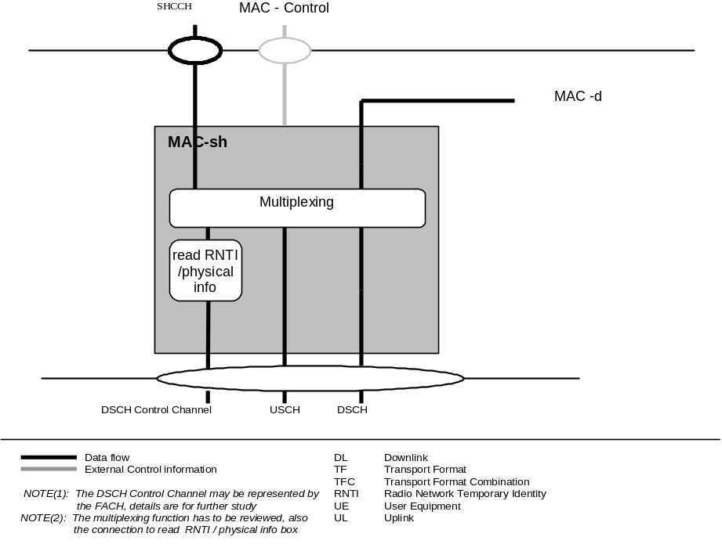

Figure 4.2.3.4. UE side MAC architecture / MAC-sh details

4.2.4. Traffic Related Architecture - RAN Side
Figure 4.2.4.1 illustrates the connectivity between the MAC entities from the RAN side. It is similar to the UE case with the exception that there will be one MAC-d for each UE and each UE (MAC-d) that is associated with a particular cell may be associated with that cell’s MAC-sh. MAC-c and Mac-sh are located in the controlling RNC while MAC-d is located in the serving RNC. The MAC Control SAP is used to transfer Control information to each MAC entity belongs to one UE. The SHCCH is used by the RRC in the controlling RNC to transfer control information to MAC-sh.

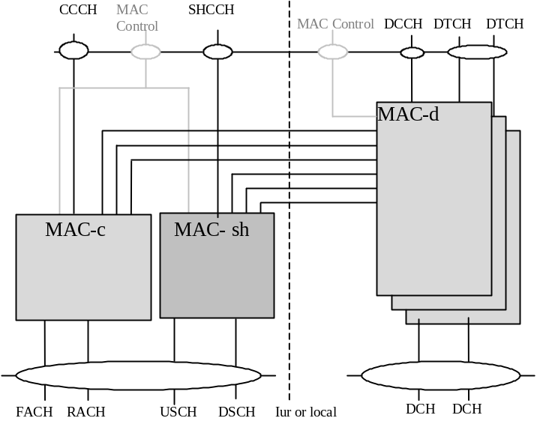

Figure 4.2.4.1: RAN side MAC architecture

Figure 4.2.4.2 shows the RAN side MAC-c entity. The following functionality is covered:

- The Scheduling – Priority Handling box manages FACH resources between the UE’s and between data flows according to their priority. DL flow control is also provided to MAC-d.
- The C/D box represents the insertion and detection of the field in the MAC header, indicating whether a common or dedicated logical channel is used.
- The D/S MUX box represents the insertion and detection of the field in the MAC header, indicating whether MAC communication to MAC-sh or to a dedicated logical channel is used.
- For dedicated type logical channels, the c-RNTI field in the MAC header is used to distinguish between UEs.
- In the downlink, transport format combination selection is done for FACH and PCH.
- The multiplexing of CTCH information and the CB-Scheduling function inside MAC-c supports the Short Message Service Cell Broadcast (SMS CB).
- The allocation box contains functionality required for USCH/DSCH operation.
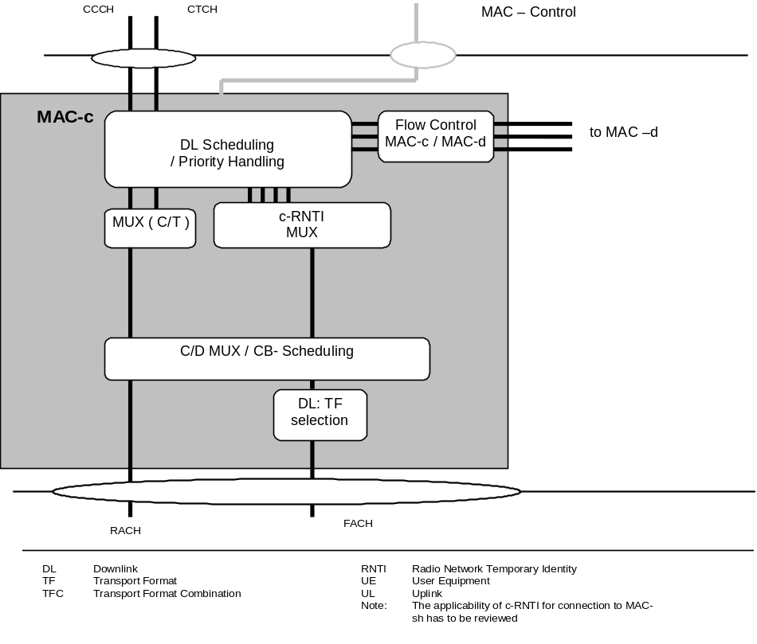

Figure 4.2.4.2 RAN side MAC architecture / MAC-c details

Figure 4.2.4.3 shows the RAN side MAC-d entity. The following functionality is covered:
- Dynamic transport channel type switching is performed by this entity, based on decision taken by RRC.
- The C/T MUX box is used when multiplexing of several dedicated logical channels onto one transport channel is used. C/T Mux is also responsible for priority setting on data received from DCCH / DTCH.
- Each MAC-d entity using common channels is connected to a MAC-c entity that handles the scheduling of the common channels to which the UE is assigned and DL (FACH) priority identification to MAC-c (priority identification of each PDU for DTCH NRT data is FFS).
- Each MAC-d entity using downlink shared channel is connected to a MAC-sh entity that handles the shared channels to which the UE is assigned and indicates the level of priority of each PDU to MAC-sh and to MAC-c.
- In the downlink, scheduling and priority handling of transport channels is performed within the allowed transport format combinations of the TFCS assigned by the RRC. This function supports the TFCI insertion in Node B.
- Codec Mode Adaptation and Inband signalling message support is used to relay the Codec Mode command request from RAN to the corresponding Transcoder.
- Support of Ciphering / Deciphering for transparent RLC operation in MAC, see [2] for details on the concept.
- A flow control function exists toward MAC-c and MAC-sh to limit buffering between MAC-d and MAC-c or MAC-sh entities. This function is intended to limit layer 2 signalling latency and reduce discarded and retransmitted data as a result of FACH or DSCH congestion. It also allows handle the quality of service if MAC-d requires it.

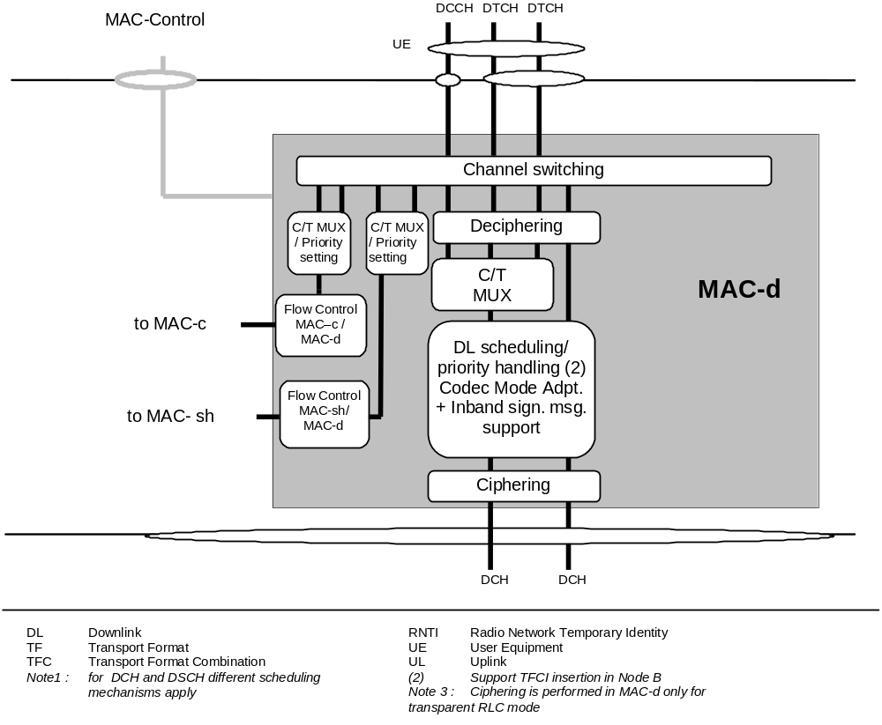

Figure 4.2.4.3 RAN side MAC architecture / MAC-d details

Figure 4.2.4.4 shows the RAN side MAC-sh entity. The following functionality is covered:
- A specific UE ID is needed when using the DSCH Control Channel to identify the UE on the DSCH. This specific UE ID may be optimised for DSCH and will be allocated when a RB is mapped onto a DSCH. Additionally, some timing information is needed to tell the UE when to listen to DSCH.
- The scheduling /priority handling box in MAC-sh shares the DSCH resources between the UEs and between data flows according to their priority. The demultiplex function is used to support the USCH and the connection to the MAC-c.
- The scheduling/priority handling box also prioritizes between UL & DL capacity allocation indications according to the instruction from SHCCH.
- DL code allocation is used to indicate the code used on the DSCH and the appropriate Transport format on the DSCH.
- Flow control is provided to MAC-d.
- Buffer occupancy information is read in order to support USCH operation.

( Note: Capacity allocation synchronization related to the USCH/ DSCH transmission is ffs. )

The RLC has to provide RLC-PDU to the MAC and they should fit into the available transport blocks on the transport channels respectively.

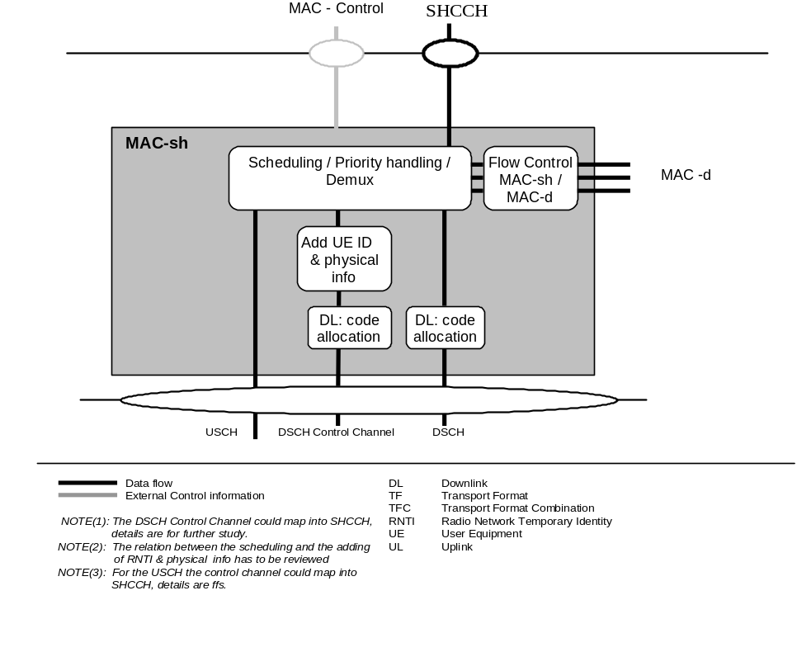

Figure 4.2.4.4 RAN side MAC architecture / MAC-sh details

4.3 Channel structure

The MAC operates on the channels defined below; the transport channels are described between MAC and Layer1, the logical channels are described between MAC and RLC. The following sections provide an overview, the normative description can be found in [2] and [3] respectively.

4.3.1 Transport channels

Common transport channel types are:
- Random Access Channel(s) (RACH)
- Forward Access Channel(s) (FACH)
- Downlink Shared Channel(s) (DSCH)
- DSCH Control Channel
- Uplink Shared Channel(s) ( USCH),
- ODMA Random Access Channel(s) (ORACH) (optional)
- Broadcast Channel (BCH)
- Synchronisation Channel (SCH)
- Paging Channel (PCH)

Dedicated transport channel types are:
- Dedicated Channel (DCH)
- ODMA Dedicated Channel (ODCH) (optional)

4.3.2 Logical Channels

The MAC layer provides data transfer services on logical channels. A set of logical channel types is defined for different kinds of data transfer services as offered by MAC. Each logical channel type is defined by what type of information is transferred.

4.3.2.1 Logical channel structure
The configuration of logical channel types is depicted in Figure 4.3.2.1:

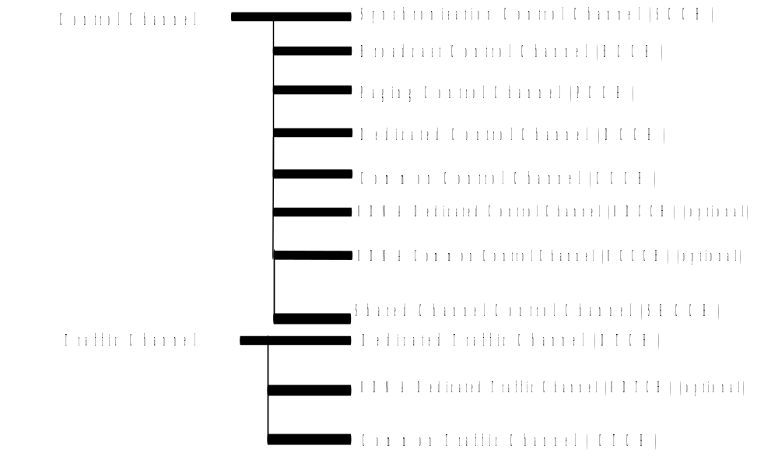

Figure 4.3.2.1: Logical channel structure

4.3.2.2 Control Channels
Following control channels are used for transfer of control plane information only:
- Synchronisation Control Channel (SCCH)
- Broadcast Control Channel (BCCH)
- Paging Control Channel (PCCH)
- Common Control Channel (CCCH)
- Dedicated Control Channel (DCCH)
- ODMA Common Control Channel (OCCCH) (optional)
- ODMA Dedicated Control Channel (ODCCH) (optional)
- Shared Channel Control Channel (SHCCH)

4.3.2.3 Traffic Channels
Following traffic channels are used for the transfer of user plane information only:
- Dedicated Traffic Channel (DTCH)
- ODMA Dedicated Traffic Channel (ODTCH) (optional)
- Common Traffic Channel (CTCH)

4.3.3 Mapping between logical channels and transport channels
The following connections between logical channels and transport channels exist:
- SCCH is connected to SCH
- BCCH is connected to BCH
- PCCH is connected to PCH
- CCCH is connected to RACH and FACH
- DCCH and DTCH can be connected to either RACH and FACH, to RACH and DSCH, to DCH and DSCH, or to a DCH.
- CTCH may be mapped to FACH and DSCH or BCH, the mapping is ffs
- DCCH and DTCH can be mapped to the USCH

5 Services provided to upper layers

5.1 Description of Services provided to upper layers

Data transfer
- Reallocation of radio resources and MAC parameters
- Reporting of measurements

The following potential service is regarded as a further study item:
- Allocation/de-allocation of radio resources

6 Functions

6.1 Description of the MAC functions

The functions of MAC include:
- Mapping between logical channels and transport channels.
- Selection of appropriate Transport Format for each Transport Channel depending on instantaneous source rate
- Priority handling between data flows of one UE
- Priority handling between UEs by means of dynamic scheduling
- Priority handling between data flows of several users on the the DSCH and FACH
- Scheduling of broadcast, paging and notification messages
- Identification of UEs on common transport channels
- Multiplexing/demultiplexing of higher layer PDUs into/from transport blocks delivered to/from the physical layer on common transport channels
- Multiplexing/demultiplexing of higher layer PDUs into/from transport block sets delivered to/from the physical layer on dedicated transport channels
- Traffic volume monitoring
- Monitoring the links of the assigned resources
- Routing of higher layer signalling
- Maintenance of a MAC signalling connection between peer MAC entities
- Dynamic Transport Channel type switching
- Ciphering for transparent RLC
- Relay Codec mode command requests generated by the RRC (e.g. relay of the AMR mode command)
- Supports inband signalling (e.g. for AMR mode adaptation)
- Fast dynamic channel allocation

The following potential functions is regarded as further study items:

- Processing of messages received at common control channels
- Successive Transmission on RACH
- Access Service Class selection for RACH transmission.

6.2 Relation between MAC Functions / Transport Channels and UE

6.2.1 Relation between MAC Functions and Transport Channels

Associated MAC Functions | Logical Ch | Transport Ch | TF Selection | Priority handling between users | Priority handling  (one user) | Scheduling | Identification of UEs | Mux/Demux on common transport CH | Mux/  Demux on dedicated transport CH | Dynamic transport CH switching
Uplink  (Rx) | CCCH | RACH |  |  |  |  |  | X
 | DCCH | RACH |  |  |  |  | X | X
 | DCCH | DCH |  |  |  |  |  |  | X
 | DTCH | RACH |  |  |  |  | X | X
 | DTCH | DCH |  |  |  |  |  |  | X
Downlink  (Tx) | SCCH | SCH
 | BCCH | BCH |  |  |  | X
 | PCCH | PCH |  |  |  | X
 | CCCH | FACH |  | X |  |  |  | X
 | DCCH | FACH |  | X |  |  | X | X
 | DCCH | DSCH |  | X |  |  |  | X
 | SHCCH | FACH |  | X |  |  |  | X
 | DCCH | DCH | X |  | X |  |  |  | X
 | DTCH | FACH | X(note1) | X |  |  | X | X |  | X
 | DTCH | DSCH | X(note2) | X |  |  |  | X |  | X
 | DTCH | DCH | X |  | X |  |  |  | X | X

Table 1 RAN MAC functions corresponding to the transport channel (note3)

(Note1) On FACH channel, the transport format set is limited.
(Note2) Whether DSCH has the transport format set is under discussion.
(Note3) The functions not included in the table are listed below.

- Mapping between logical channels and transport channels.
- Traffic volume monitoring
- Constrained execution of open loop power control algorithms

Further, the following additional functions are not included yet in the table:
- Routing of higher layer signalling
- Maintenance of a MAC signalling connection between peer MAC entities
- Monitoring the links of the assigned resources
- Processing of messages received at common control channels

Note ( this table has to be reviewed )

6.2.2 Relation of UE MAC functions corresponding to the Transport Channel MAC Functions and Transport Channels

Functions | Logical Ch | Transport Ch | TF Selection | Priority handling data of one user | Identification | Mux/Demux on common transport channels | Mux/Demux on dedicated transport channels | Dynamic transport channel type switching
Uplink  (Tx) | CCCH | RACH |  |  |  | X
 | DCCH | RACH | X(note1) |  | X | X
 | DCCH | DCH | X | X |  |  | X
 | DTCH | RACH | X(note1) |  | X | X |  | X
 | DTCH | DCH | X | X |  |  | X | X
Downlink  (Rx) | SCCH | SCH
 | BCCH | BCH
 | PCCH | PCH
 | CCCH | FACH |  |  |  | X
 | DCCH | FACH |  |  | X | X
 | DCCH | DSCH |  |  |  | X
 | DCCH | DCH |  |  |  |  | X
 | SHCCH | FACH |  |  |  | X
 | DTCH | FACH |  |  | X | X
 | DTCH | DSCH |  |  |  | X
 | DTCH | DCH |  |  |  |  | X

Table 2 UE MAC functions corresponding to the transport channel

(Note1) The RACH channel has the limited transport format set.

Note: This table has to be reviewed

7 Services expected from physical layer

see TS C002

8 Elements for layer-to-layer communication

8.1 Primitives between layers 1 and 2

see TS C002
It is proposed to add some position information for baton handover to the SHY-DATA primitive parameter (the details is ffs)

8.2 Primitives between MAC and RLC
It is proposed to add some position information to the MAC-DATA primitive parameter (the detail is ffs)

8.2.1 Primitives

The primitives between MAC layer and RLC layer are shown in Table 8.2.1.1

Generic Name | Type |  |  |  | Parameters
 | Request | Indication | Response | Confirm
MAC-DATA | X | X |  |  | MU, BA, TD
MAC-ERROR |  | X |  |  | [ FFS ]
MAC-STATUS |  | X | X |  | [ FFS ]

Table 8.2.1 Primitives between MAC layer and RLC layer

MAC-DATA Request/Indication
- MAC-DATA Request primitive is used to request that an upper layer PDU be sent using the procedures for the information transfer service.
- MAC-DATA Indication primitive indicates the arrival of an upper layer PDU received by means of the information transfer service.

MAC-ERROR Indication
- MAC-ERROR Indication primitive indicates to RLC that an error condition has occurred.

MAC-STATUS Indication/Response
- MAC-STATUS Indication primitive indicates to RLC about changes in the rules under which it may transfer data to MAC. Parameters of the primitive can indicate a transmission timer value, whether the RLC can transfer data and whether that data is restricted to supervisory frames only.
- MAC-STATUS Response enables RLC to acknowledge a MAC-STATUS Indication. It is possible that RLC would use this primitive to indicate that it has nothing to send or that it is in a suspended state.

8.2.2 Parameters

a) Message Unit (MU)
It contains the RLC layer message ( RLC-PDU) to be transmitted or received by the MAC sub-layer.
b) Buffer Amount (BA)
- The parameter Buffer Amount (BA) indicates the amount of data that is currently queued for transmission (or retransmission) in RLC laye
- RX Timing Deviation (TD)
It contains the RX Timing Deviation as measured by the physical layer for the physical resources carrying the data of the Message Unit. This parameter is optional and only for Indication. It is needed for the transfer of the RX Timing Deviation measurement of RACH transmissions carrying CCCH data to RRC.

8.3 Primitives between MAC and RRC

8.3.1 Primitives

The primitives between MAC and RRC are shown in Table 8.3.1

Generic Name | Type |  |  |  | Parameters
 | Request | Indication | Response | Confirm
CMAC-CONFIG | X |  |  |  | CHI, IAN,  UE information elements,  RB information elements,  TrCH information elements,  RACH transmission control elements,  Ciphering elements
CMAC-CONFIG |  |  |  | X | CHI
CMAC-CONNECT | X |  |  | X | ffs
CMAC-MEASUREMENT | X | X |  |  | Measurement information elements for Req,;  Measurement result for Ind
CMAC-STATUS |  | X |  |  | Status info.
CMAC-ERROR |  | X |  |  | Reason for error
CMAC-CDATA | X | X |  |  | FFS

Table 8.3.1 Primitives between MAC sub-layer and RRC

CMAC-CONFIG Request/Confirm
- CMAC-CONFIG Request is used to request for the switching the connection between logical channels and transport channels
- CMAC-CONFIG Confirm is used to inform RRC about the result of the CMAC-CONFIG Request operation, such as the process-id or the SAP identification for various communication channels, etc. Typically, at RNC a MAC-d entity has to be instantiated or a new logical channel/transport channel to be configured to work, the process-id or SAP-id has to be returned to RRC to further the operation.

CMAC-CONNECT Request/Confirm
- CMAC-CONNECT Request is used initiate a RRC connection
- CMAC-CONNECT Confirm is used to confirm the establishment of a RRC connection.

CMAC-MEASUREMENT Request/Indication
- CMAC-MEASUREMENT Request is used to request to measure something such as radio quality at both BS and MS sides. (for example : Transport Block Error)
- CMAC-MEASUREMENT. Indication is used to notify measuring result.

CMAC-STATUS Indication
- CMAC-STATUS Indication primitive notifies the management entity of status information.

CMAC-ERROR Indication
- CMAC-ERROR Indication primitive notifies the management entity of an error detected in the operation of the MAC sub layer protocol such as excessive number of transmission attempts for Ack-mode. and timer time out.

CMAC-CDATA Request
- CMAC-CDATA Request is used by RRC to request sending the RRC control signals, i.e. the RRC URA Update or the RRC Cell Update messages.

CMAC-CDATA Indication
- CMAC-CDATA Indication is used to indicate to the RRC the arrival of the control signals, i.e. the RRC URA Update or the RRC Cell Update messages.

8.3.2 Parameters

- Channel Information (CHI)
Channel information for active transport channel. For example, common channel or dedicated channel notification in user packet transmission.
- Measurement information elements
- Mode
- THU
- THL (Optional), when smart antenna adopted, the value of THL should be adopted.
- Measurement quantity indicator
- Measurement Period
- Report Interval

- Measurement result
- Mode
- Reporting Quantity
- Event

It is proposed to add some position information for baton handover to the CMAC-MEASUREMENT primitive parameter(the details is ffs)

- Status info
It is management entity of status information.

- Reason for error
It contains the management entity of an error detected in the operation of the MAC sub layer protocol (e.g. excessive number of transmission attempts for Ack-mode).

- Initial Access Number (IAN)
Initial access number is used as UE-Id in the initial access message for RRC connect request over CCCH/RACH. TMSI+LAI are used .
- UE information elements
S-RNTI
SRNC identity
C-RNTI
Activation time
- RB information elements
RB multiplexing info (Transport channel identity, Logical channel identity, MAC logical channel priority)
- TrCH information elements
Transport Format Combination Set
- RACH transmission control elements
Persistence value P
Maximum number of preamble ramping cycles M_{max}
Others (ffs., e.g. minimum and maximum number of time units between two preamble ramping cycles)
- Ciphering elements
Ciphering mode
Ciphering key
Ciphering sequence number

9 Elements for peer-to-peer communication

9.1 Protocol data units

9.1.1 MAC Data PDU

MAC PDU consists of an optional MAC header and a MAC Service Data Unit (MAC SDU), see figure 9.1.1. Both the MAC header and the MAC SDU are of variable size.

The content and the size of the MAC header depends on the type of the logical channel, and in some cases none of the parameters in the MAC header are needed.

The size of the MAC-SDU depends on the size of the RLC-PDU, which is defined during the setup procedure.

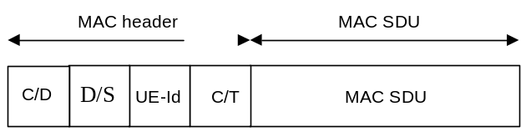

Figure 9.1.1.1 MAC data PDU

9.1.2 MAC Control PDU

MAC Control PDU consist elements for the control of the operation. The details are ffs.

9.2 Formats and parameters

9.2.1 MAC Data PDU: Parameters of the MAC header

The following fields are defined for the MAC header:

- C/D field
The C/D field is a single-bit flag that provides identification of the logical channel class on FACH and RACH transport channels, i.e. whether it carries CCCH or dedicated logical channel information.

C/D field | Designation
1 | CCCH
0 | DCCH or DTCH

Table 9.2.1.1: Coding of the C/D Field

- C/T field
The C/T field provides identification of the logical channel instance when multiple logical channels are carried on the same transport channel. The C/T field is used also to provide identification of the logical channel type on dedicated transport channels and on FACH and RACH when used for user data transmission. The size of the C/T field may be variable.

C/T field  (e.g.  4 bits ) | Designation
0000 | Logical channel 1
0001 | Logical channel 2
... | ...
1111 | Logical channel 16

Table 9.2.1.2: Structure of the C/T field

- D/S field
The D/S field is a single-bit flag that indicates whether communication to MAC-sh is applied or a dedicated logical channel is used.

D/S field | Designation
1 | MAC-sh
0 | Dedicated logical channel

Table 9.2.1.3: Coding of the D/S Field

- UE-Id
The UE-Id field provides an identifier of the UE . The following types of UE-Id are currently defined:

s-RNTI , this UE Id is related to the serving RNC
c-RNTI, this UE Id is related to the controlling RNC.

In addition for UE’s having a RRC connection the S-RNC identifier exist.

s-RNTI together with S-RNC identifier is used for URA update RRC connection reestablishment and RAN originated paging messages and there associated responses.

c-RNTI is used as a UE identifier in all other DCCH/DTCH common channel messages on the air interface.

UE-Id Type sub-field inside the UE-Id field is needed to ensure the correct decoding of the UE-Id field in MAC Headers.

The UE-Id Type sub-field definition:

UE-Id Type sub-field  2 bits | UE-Id Type
00 | CN allocated identifier (e.g. TMSI+LAI)
01 | s-RNTI + SRNCID
10 | c-RNTI
11 | For future use

Note: Whether or not other UE-Id types are needed is ffs.

9.2.1.1 MAC header for DTCH and DCCH

- DTCH or DCCH mapped to DCH, no multiplexing of dedicated channels on MAC:
No MAC header is required.

- DTCH or DCCH mapped to DCH, with multiplexing of dedicated channels on MAC:
C/T field is included in MAC header.

- DTCH or DCCH mapped to RACH/FACH:
D/S field ,C/D field and UE-Id are included in the MAC header. C/T field is included if multiplexing on MAC is applied.

- DTCH or DCCH mapped to RACH/FACH, where DTCH or DCCH are the only channels (ffs).
D/S field and UE-Id field are included in MAC header. C/T field is included if multiplexing on MAC is applied.

- DTCH or DCCH mapped to DSCH:
The MAC-PDU format for DSCH is left for further study.

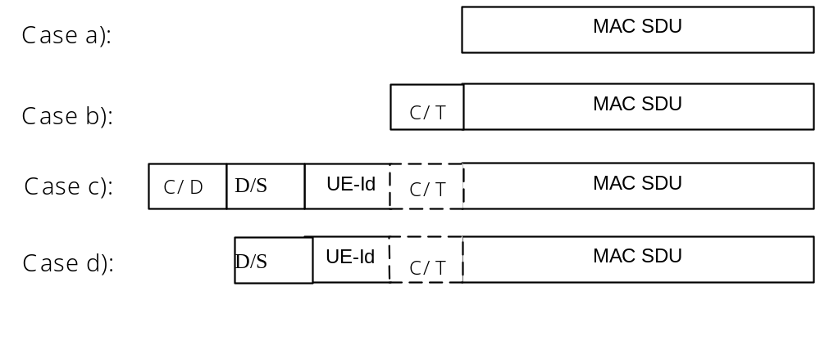

Figure 9.2.2.1: MAC Data PDU formats for DTCH and DCCH

9.2.1.2 MAC header for CCCH

Note: The concept for using UE Id on CCCH has to be reviewed

- CCCH mapped to RACH/FACH:
C/D has to be included and UE-id field may be included in MAC header. Details of usage the UE-id field is ffs.
- CCCH mapped to RACH/FACH, where CCCH is the only channel (ffs):
UE-id field may be included in the MAC header.

Note: The usage of the MAC header for BCCH and PCCH is ffs.
The address used for initial addressing is ffs, a possible solution may be to use a Random .

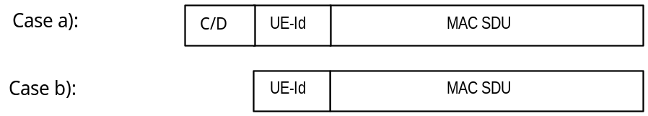

Figure 9.2.1.2.1 : MAC Data PDU formats for CCCH

9.2.1.3 MAC Header for CTCH

The MAC header for CTCH mapped to FACH is as shown in figure 9.2.1.3.1

Figure 9.2.1.3.1 : MAC Data PDU format for CTCH

C/D field indicates whether data is mapped to the common or dedicated logical channel.
C/T field indicates whether it belongs to CCCH or CTCH. In case of CTCH, it identifies whether the message is SMS CB message or Schedule message

9.2.2 Control PDUs

MAC Control PDU elements have to be described, the details are ffs.

9.3 Protocol states

(Description of states, provision of state transition diagram(s))

9.4 State variables

9.5 Timers

9.6 Protocol Parameters
(e.g. max, min values of state variables to be initialised)

9.7 Specific functions

9.7.1 Fast Dynamic Channel Allocation for Bearer Service
Fast channel allocation refers to the allocation of one or multiple physical channels to any bearer service Resource units (RUs) are acquired (and released) according to a cell-related preference list derived from the slow DCA scheme.
The following principles hold for fast channel allocation:
- The basic RU used for channel allocation is one code / time slot / (frequency).
- Multi-rate services are achieved by pooling of resource units. This can be made both in the code domain (pooling of multiple codes within one time slot = multi-code operation) and time domain (pooling of multiple time slots within one frame = multi-slot operation). Additionally, any combination of both is possible.
- Since the maximum number of codes per time slot in UL/DL depends on several physical circumstances like, channel characteristics, environments, etc. (see description of physical layer) and additional techniques (for example smart antennas and joint detection) to enhance capacity are applied, the DCA algorithm has to be independent of this number. Additionally, time hopping can be used to average inter-cell interference in case of low-medium bit rate users.
- Channel allocation differentiates between RT and NRT bearer services:
- RT services: Channels remain allocated for the whole duration the bearer service is established. The allocated resources may change because of a channel reallocation procedure (e.g. VBR).
- NRT services: Channels are allocated for the period of the transmission of a dedicated data packet only UDD channel allocation is performed using ‘best effort strategy’, i.e. resources available for NRT services are distributed to all admitted NRT services with pending transmission requests. The number of channels allocated for any NRT service is variable and depends at least on the number of current available resources and the number of NRT services attempting for packet transmission simultaneously. Additionally, prioritization of admitted NRT services is possible.
- Channel reallocation procedures (intra-cell handover) can be triggered for many reasons:
- To cope with varying interference conditions.
- In case of high rate RT services (i.e. services requiring multiple resource units) a channel reshuffling procedure is required to prevent a fragmentation of the allocated codes over to many timeslots. This is achieved by freeing the least loaded timeslots (timeslots with minimum used codes) by performing a channel reallocation procedure.
When using smart antennas, channel reallocation is useful to keep spatially separated the different users in the same timeslot.

10 Handling of unknown, unforeseen and erroneous protocol data

11 Elementary procedures

Examples: data transfer, random access procedure, transport channel type switching (dedicated/common channel)

11.1 Dynamic Radio Bearer control

Dynamic Radio Bearer control is performed in RRC, based on the traffic volume measurement reported by MAC. Traffic volume information is gathered and measured in MAC layer and the result is reported from MAC layer to RRC layer.
Traffic volume monitoring procedure in MAC is shown in figure 11.1.1. MAC receives RLC PDUs with the status information of RLC transmission buffer. Every transmission time interval, MAC compares the amount of transferred data corresponding to a Transport Channel with the thresholds set by RRC. If the value is out of range, MAC indicates the measurement reports on traffic volume status to RRC. Thereby, RRC can be informed the traffic volume status of each transport channel, and therefore can make a decision for new Radio Bearer configuration accordingly.
RRC requests MAC measurement report with the primitive CMAC-Measure-REQ including following parameters.

Measurement information elements
- Mode
Indicates whether the report should be periodically or by event-triggered way
- THU
Upper threshold value for every transport channel, applicable when mode is event-triggered
- THL (Optional)
Lower threshold value for every transport channel, applicable when mode is event-triggered
- Measurement quantity indicator
Indicates what should be reported to RRC layer
For each RB, Buffer amount (mandatory), Variance (optional), or Average (optional)
- Measurement Period
The period during which the average and variance is measured, applicable such quantities are required
- Report Interval
Indicates the report interval, applicable when report mode is periodic
MAC receives RLC PDUs with the primitive MAC-Data-REQ including following parameters:
- Data (RLC PDU)
- Buffer Amount (BA)
The parameter Buffer Amount (BA) indicates the amount of data that is currently queued for transmission (or retransmission)
MAC receives measurement information elements with the primitive CMAC-Measure-REQ which includes parameters such as Mode, mesurement period, report interval, and THL and THU for each transport channel. Whenever MAC receives RLC PDUs from different RLC entities, it is notified by RLC amount of data queued in RLC transmission buffer. If the mode is an event-triggered way, MAC compares the amount of data to be transmitted on a transport channel and threshold passed by RRC, THL and THU. In case that the measured value is out of range, MAC reports the status of result of comparison and status of each RB to RRC. On the other hand, if the mode is periodic way, MAC reports measurement result to RRC periodically. Measurement result can contain average and variance as well as amount of data for each RB with CMAC-Measure-IND primitive as follows:
Measurement result
- Mode
Periodic, or event-triggered
- Reporting Quantity
For each RB, Buffer amount (mandatory), Variance (optional), or Average (optional)
- Event
Indicates which threshold triggers the report, THU, or THL for which transport channel, applicable when mode is event-triggered

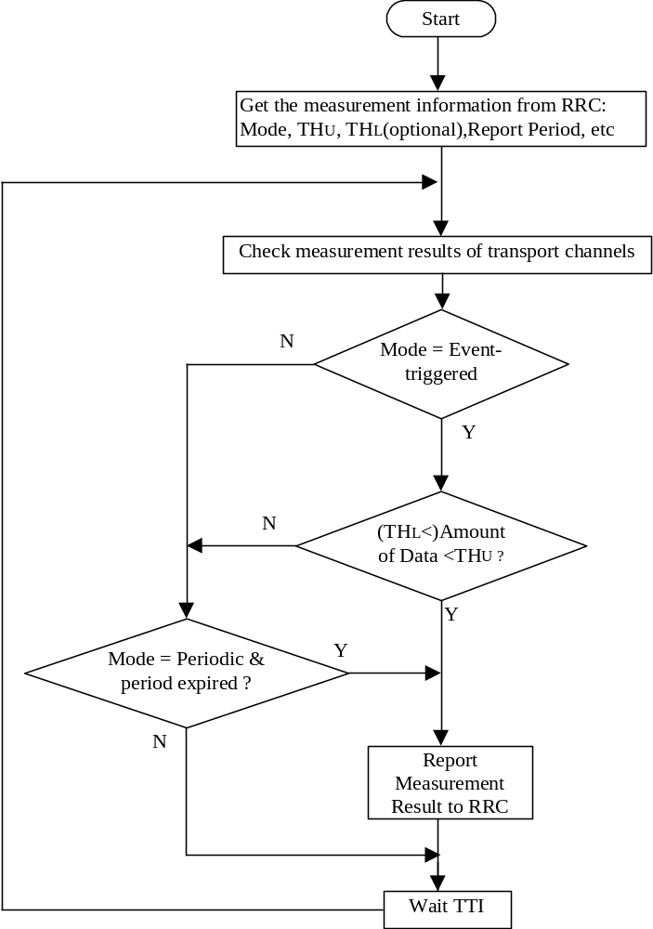
Figure 11.1.1: Dynamic Radio Bearer control procedure

11.2 Control of RACH transmissions

The MAC sublayer is in charge of controlling the timing of RACH transmissions on transmission time interval level (i.e. on 5ms TDD subframe level; the timing on access slot level is controlled by L1). MAC controls the timing of each initial preamble ramping cycle as well as successive preamble ramping cycles in case that none or a negative acknowledgement is received. Note that retransmissions in case of erroneously received RACH message part are under control of higher layers (i.e. RLC, or RRC for CCCH data).
The RACH transmissions are performed by the UE as shown in Figure 2. MAC receives the following RACH transmission control parameters from RRC with the CMAC-Config-REQ primitive:
- persistence value P (transmission probability),
- maximum number of SYNC1 retransmission cycles M_{max},
- others (ffs., e.g. minimum and maximum number of time units between two SYNC1 transmission cycles).
Based on the persistence value P, the UE decides whether to start the L1 SYNC1 transmission procedure in the present transmission time interval or not. If transmission is allowed, the L1 SYNC1 transmission procedure is started. MAC then waits for status indication from L1. If transmission is not allowed, a backoff timer T_{BO1} is started and another attempt is performed after expiry of the timer.
When the SYNC1 has been acknowledged on FACH, the RACH message part is transmitted according to L1 specifications. When no acknowledgement is received, a backoff timer T_{BO2} is started and another SYNC1 transmission cycle is performed. In case that a negative acknowledgement has been received on FACH a backoff timer T_{BO3} is started. After expiry of the timer persistence check is performed again.
The settings of the backoff timers T_{BO1,} T_{BO2,} T_{BO3} is ffs. The setting is an integer number (≥ 1) of transmission time intervals, either fixed or randomly drawn from an interval defined by RACH transmission control parameters received from RRC, which might be updated dynamically, together with update of persistence value.
[Note: The three timers are introduced at this stage mainly to keep the algorithm most general. Possibly T_{BO1} and T_{BO2} can simply be set to their minimum value, which is currently assumed to be 10 ms. However, smaller backoff timing units such as access slot intervals may also be considered. The introduction of random backoff withT_{BO3} could especially be useful when the update time for the persistence value is low, i.e. larger than a radio frame.]

The backoff algorithm encompasses currently both
- a persistency check and
- a backoff time
at both stages,
- initial (i.e. very first) attempt after the request to send RACH data has been received by MAC, and
- subsequent attempt, which is needed in case of the following conditions:
- after an unsuccessful SYNC1 transmission cycle (No Ack)
- after a Nack from L1.
For both stages it is FFS if both (a) and (b) are needed or if one of (a) or (b) is sufficient.

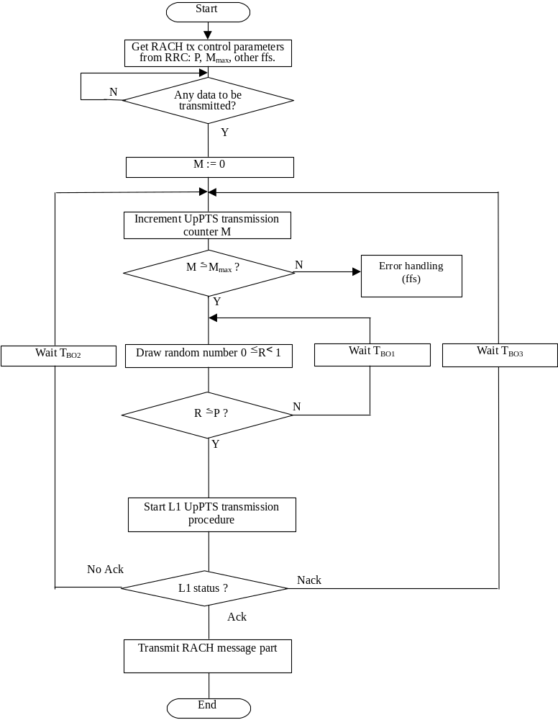

Figure 11.2.1 : RACH transmission control procedure (UE side, informative)

12 History

Document history
Date | Version | Comment
4th August 1999 | 1.0.0 | Document created. Based on TSG RAN WG2 TS 25.321 V3.0.0 at Chongqing Univ. Of Posts&Telecom.
30th August, 1999 | 2.0.0 | After discussion in CWTS WG1 Ad Hoc1 #3 meeting, the MAC-p entity is deleted.
14th October, 1999 | 3.0.0 | After discussion in CWTS WG1 Ad Hoc1#4 CWTS WG1 #5 meeting, the controlling function of MAC-c for MAC-sh is removed. The corresponding controlling function is replaced by the uplayer entity and a SHCCH logical channel is introduced.
Rapporteur for TS C201 is:
Simin Xiong
Chongqing Univ. of Posts&Telecom.

Tel.: +86 23 6246 0347
Fax: +86 23 6246 1882
GSM:.+86 1370 836 9523
e-mail: xiongsm@cqupt.edu.cn
This document is written in Microsoft Word Chinese Version 97 and saved in Rich Text Format.

Annex A (informative):

Description of random access procedure

A.1 Assumptions

The following assumptions for RACH transmission are made (for completeness assumptions are made also for other layers than MAC):
UE side:
- PRACH transmissions are triggered by data request from MAC to PHY (PHY-Data-REQ). This implies that any desired backoff in PRACH transmissions is controlled by MAC (or higher layer).
- The physical layer uses the PHY-Status-IND primitive to indicate the following conditions to MAC:
- Maximum SYNC1 transmit power reached, no acknowledgement on FACH received,
- Negative acknowledgement received on FACH (”Nack”) indicating that the SYNC1 has been acquired, but transmission of the message shall be suspended,
- Positive acknowledgement received on FACH (”Ack”), RACH message has been transmitted,
- The following PRACH parameters are configured by RRC through C-SAP by means of CPHY-TrCH-Config-REQ primitive:
- initial transmit power,
- power increasing step size,
- SYNC1-to-message payload transmit power offset,
- PRACH maximum power
- PRACH spreading code,
- Access Service Class (ASC) parameters (ffs.).
- Synchronisation Shift
- Configuration of FACH parameters by RRC (using CPHY-TrCH-Config primitive)
- FACH spreading code
- timing information for search of acquisition indicator (if needed)
- The following parameters are randomly selected by the physical layer (possibly within constraints defined by ASC parameters):
- PRACH initial access slot,
- PRACH signature
RAN side:
- Continuous monitoring of the PRACH is handled by layer 1 procedures. There is only a single primitive needed between PHY and MAC, indication of data (PHY-Data-IND).

A.2 Example message sequence for random access procedure

RACH transmissions are split into two phases, SYNC1 transmission and message transmission. The message is transmitted when acquisition of the SYNC1 has been acknowledged, where a fixed timing between that last transmitted SYNC1, the acquisition indicator and the message needs to be maintained. Under certain conditions (see below) it will be necessary to perform multiple attempts of SYNC1 transmission before the message can be sent.
The timing of RACH transmissions on transmission time interval level is controlled by the MAC sublayer (i.e. introduction of backoff delay based on transmission time interval units).
An example message sequence for random access is shown in Figure 1. RACH transmission is performed as follows:
The RACH and FACH are configured once via a CPHY-TrCH-Config-REQ primitive. This primitive needs to be issued only for initial configuration or when a parameter shall be changed, not for every RACH transmission.
The CMAC-Config-REQ primitive is used to configure MAC parameters required for the random access procedure. The parameters could include random access control parameters such as, e.g. persistence value, maximum number of SYNC1 transmission cycles, and minimum and maximum backoff time in terms of number of transmission time intervals (i.e. radio frames of 10 ms) when transmission is allowed.
[Note: Above listed access control parameters are only examples for further study. Also it is ffs how the access control parameters are obtained by RRC from e.g. broadcast information.]
When there is data to be transmitted on the RACH, i.e. reception of a MAC-Data-REQ primitive, the RACH transmission control procedure is started.
After some initial backoff, a primitive PHY-Data-REQ is sent to L1, which triggers the PRACH SYNC1 transmission procedure, i.e. the physical layer selects a PRACH access slot without further backoff delay imposed on L1 (possibly within ASC constraints). Note that the initial backoff time may in certain conditions be set to zero (e.g. when the uplink load is low).
In the example it is assumed that the SYNC1 transmission procedure is completed with one of the following conditions:
- maximum SYNC1 transmission power was reached without receiving an acknowledgement, or
- a negative acknowledgement (Nack) has been received on FACH.

The first condition can be due to following reasons:
- missed SYNC1 in Node B at max power due to detection probability <1,
- collision with another user,
- an acknowledgement was sent but it was missed at the UE.
This condition should occur very rarely and may not necessarily require backoff for a repetition of the SYNC1 transmission cycle (except case 1.) is due to overload, which however should be prevented by the system in some suitable way). However some backoff should be imposed to provide a better interference distribution over time.
The second condition, reception of ”Nack” on FACH, shall be used to prevent the user from sending his message in case of danger of a temporary congestion (it could be ignored by ”special users”). In this case, a new access attempt should be started by MAC after some further backoff delay. Note that this ”subsequent” backoff time might be calculated differently than the initial backoff time applied in the first SYNC1 transmission cycle. Also, the subsequent backoff time may be set differently for either of the above conditions (i) and (ii).
This condition could occur a number of consecutive times. The number of SYNC1 transmission cycles is counted on MAC. When the maximum number of cycles is exceeded an error condition is signaled to RRC (with CMAC-Status or CMAC-Error primitive, ffs.) and the MAC PDU is removed.
Upon successful transmission of a SYNC1, MAC receives an acknowledgement via PHY-Status-IND primitive that the acquisition indicator was received and the message sent.
At the RAN-side MAC the further processing of received RACH message depends on the MAC header. An acknowledgement that the message was received correctly is either be given by RRC procedure or by a RLC retransmission procedure, depending on the type of the message. The parameters of PRACH transmission are chosen such that retransmission of the messages is a very rare event. Incorrectly received messages should not be due to overload situations since this condition should have been signaled via the Nack on FACH after preamble acquisition. It is thus not needed to impose an additional outer backoff time for retransmission of the message. Message retransmission shall be handled entirely on RLC, or RRC for CCCH messages, employing retransmission timers.
It should be noted that for transmission on common transport channels some parameters of the RLC retransmission protocol may need to be updated to cope with delays introduced by the MAC RACH transmission control function.
[Note: An additional negative acknowledgement (Nack) given by L1 for erroneously received RACH message part is ffs.]
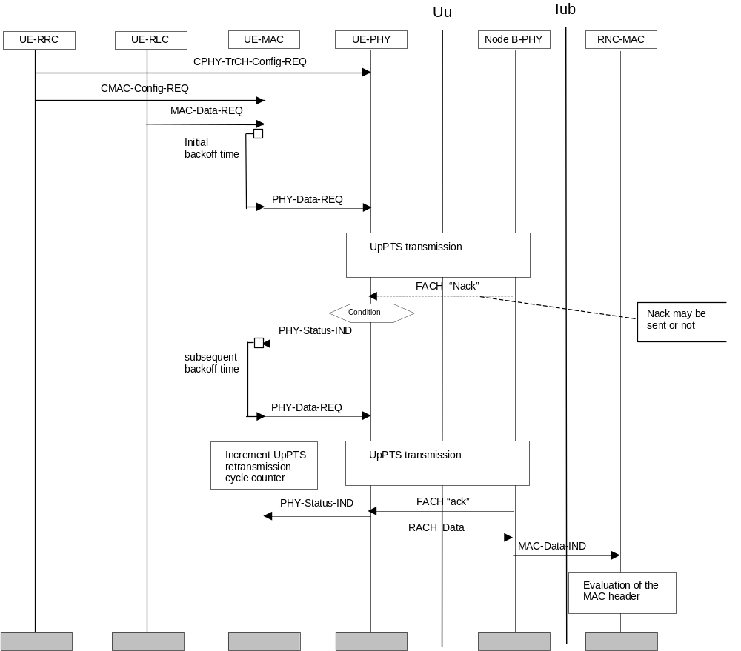
Figure A.1: Example random access transmission sequence

